Homework 3

Mariam Mkrtichyan

Part 1:

1. Does battery capacity influence the launched price of a smartphone? Check this variability across all currencies. Is there any type of difference between behaviors?

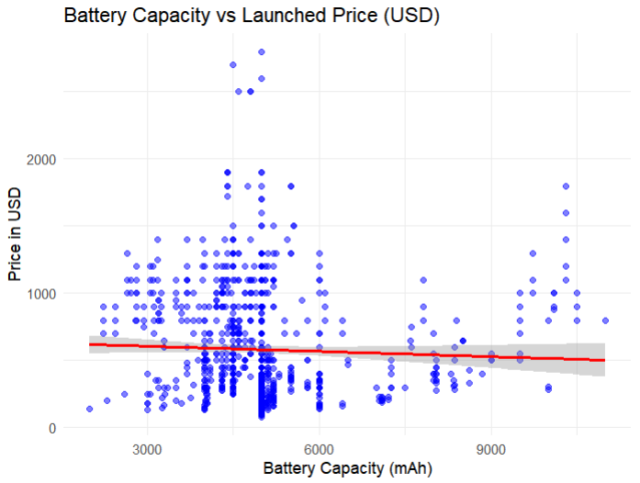No correlation or little negative correlation is suggested based on scatter plot. Phones with similar battery capacity(3500-6000mAh) have a wide range of prices. Some phones with (<=3000) are priced higher. We can conclude no or little relation. Ensure RAM is numeric by removing non-numeric characters and

#converting

2. Does RAM size impact the price of smartphones? Check this variability across all currencies. Is there any type of difference between behaviors?

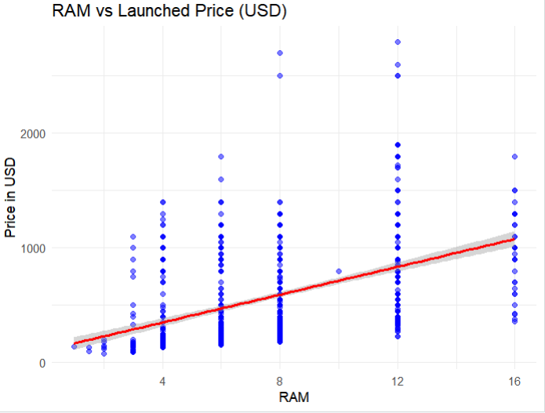Certainly, there is relation between lower of margin of prices and RAM size as we can notice that minimum price depend on RAM size but price is not only correlated to RAM size as with low RAM size there are phones with higher price which will be due to other attributes of phone.

3. Do Apple devices have a higher price variation across different regions compared to other brands? In which country do Apple devices have the highest markup? Are there brands with more stable pricing across regions?

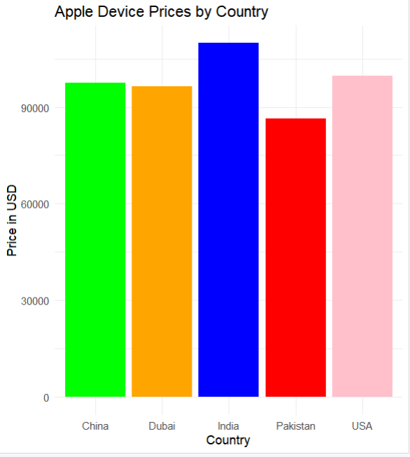Apple devices in India and USA are much higher compared to Pakistan Dubai and Chaina.

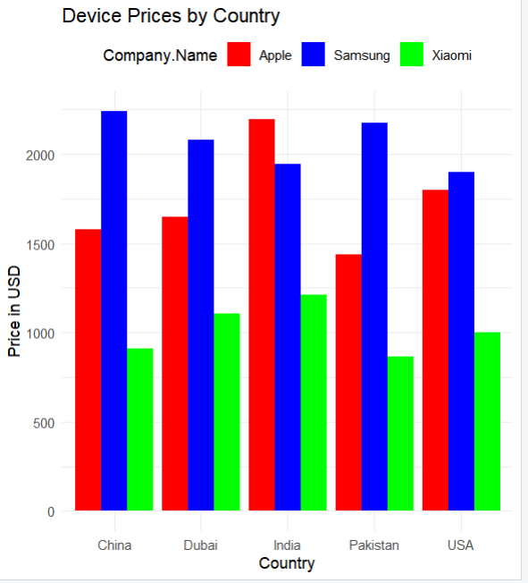Xiaomi price is relatively constant over different countries. Apple price in China and Dubai is nearly same.

4. Do all smartphone brands have flagship and budget-friendly models, or do some brands only focus on premium devices? Hint: Categorize brands into budget, mid-range, and premium segments (Budget: < $300, Mid-range: $300 - $700, Premium: > $700). Check how many models each brand has in each segment. Determine whether a brand covers all three segments or focuses only on premium/mid-range.

Apple, Google, Sony and Huawei companies are focused on premium/mid-range production. Here we can see that Apple has more focus on premium device production. But there are companies like Samsung, Honor, Tecno, Vivo and Xiaomi that produce all kind of devices.

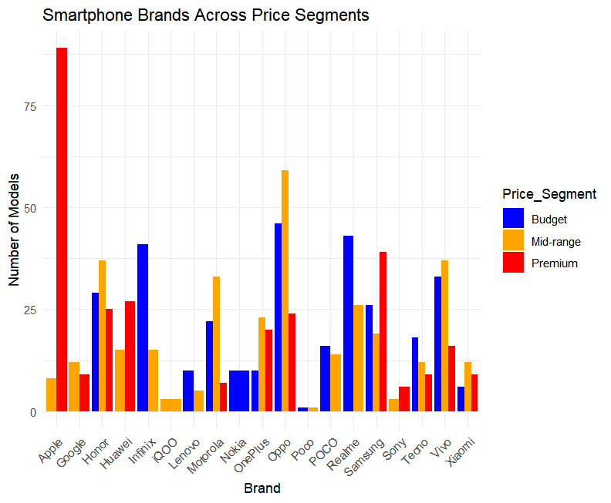

5. Which region offers the most affordable smartphone prices on average? Are there any brands that price their phones significantly lower in one region compared to others?

In case of Pakistan and China prices of Xiaomi devices are much lower compared to other countries also Pakistan’s Apple prices are much lower compared to other countries. Samsung device prices have lower price in India.

Part 2: Visualization (Python & R)

1. Plot a bar chart for average price per region in USD.

2. Create a pie chart of the market share of smartphone brands.

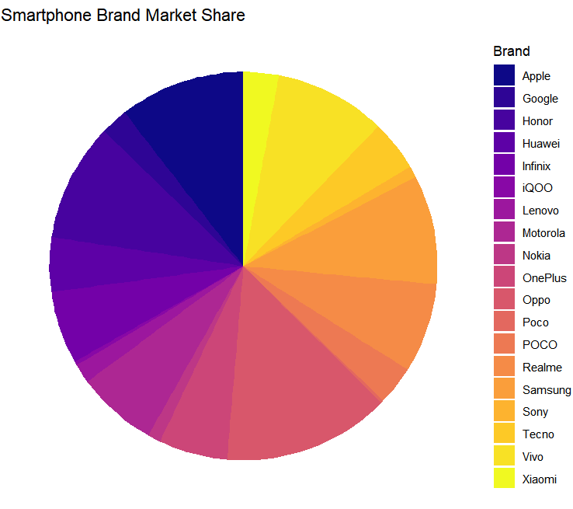

Problem 3 Recreate graphs

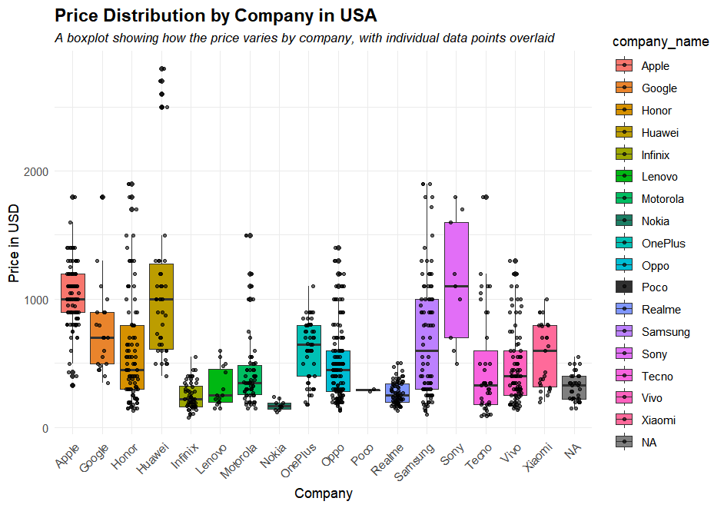

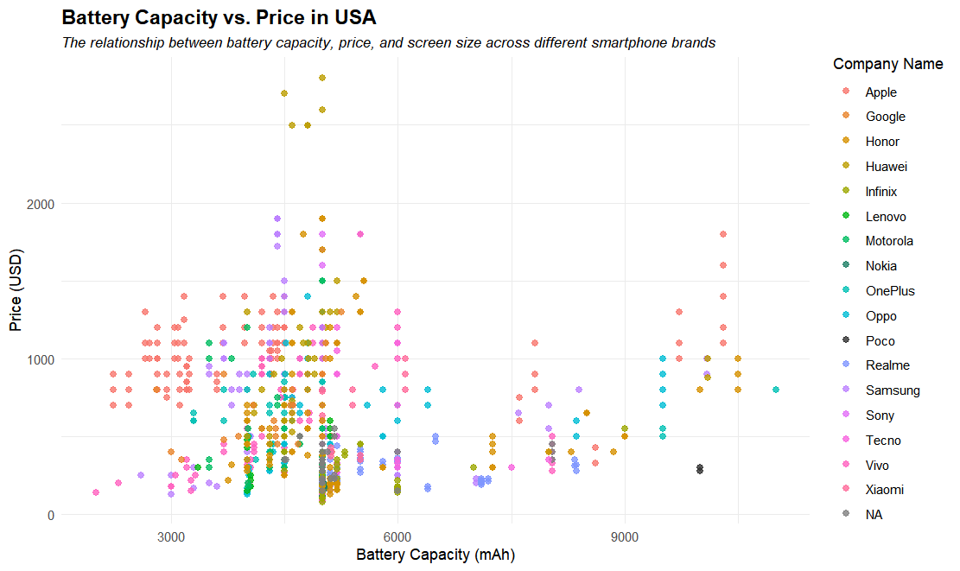

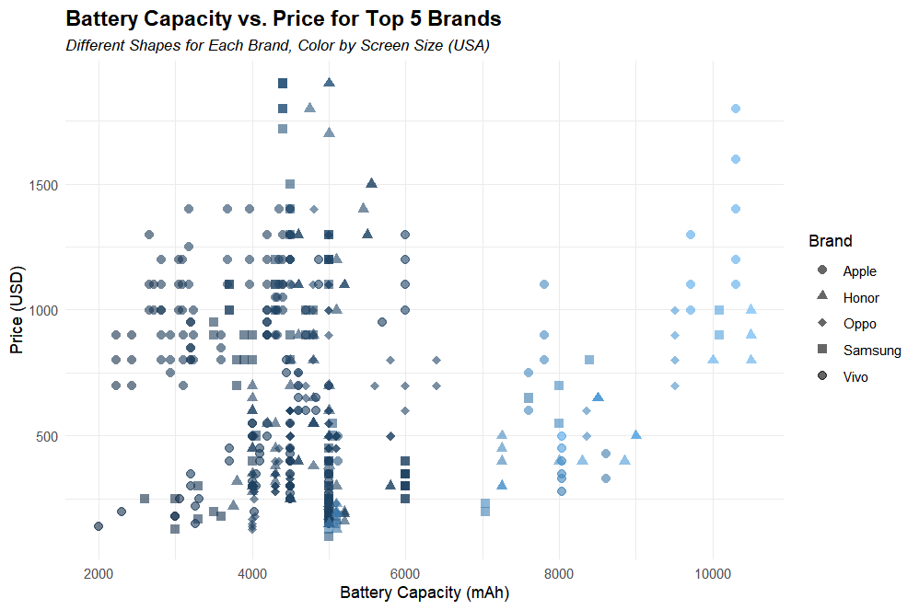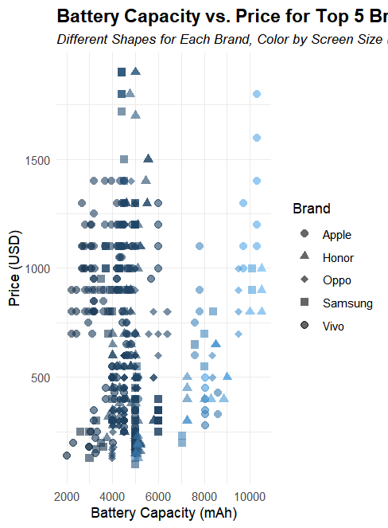

Problem 4.

Camera Relation to Price change in USA

We can notice the correlation between screen size and Price we can see there is a increasing trend line across values. Here we can conclude that Camera capacity place a crucial role in device prices.

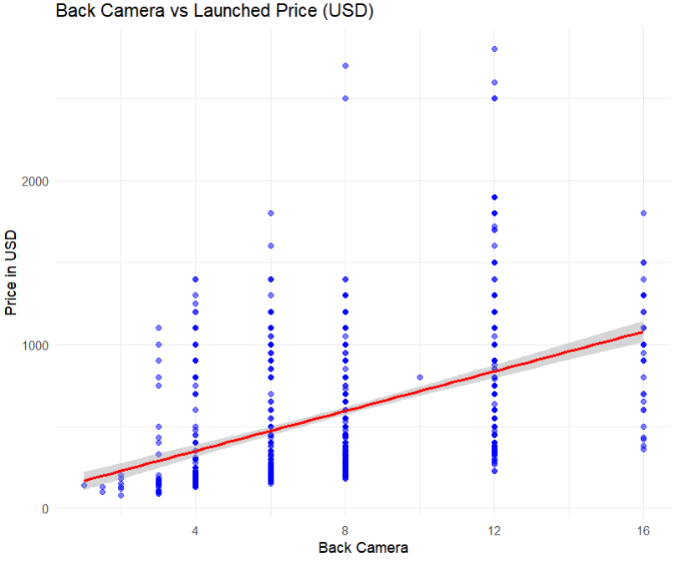

Screen size has wide range of prices very high prices are for medium size devices.

